**CIMDes ReadMe**

Sai Muppana

Kiran Siddappaji

Mark G. Turner

University of Cincinnati

CIMDes is a centrifugal impeller meanline design code. It performs 1D analysis of centrifugal impeller for single and multi-stages. Below are the instructions to run it.

CIMDes is a Python script and it can be run from any machine which has Python 3.6 installed.

Inputs: inputs.py - the inputs are in the python script itself.

spancontrolinput.X.dat – spanwise control input for blade curvature and camber.

Outputs: veltri.png – image of velocity triangles at the hub.

streamlines.png – flow path in x-r coordinates.

bladerow.png – relative blade angles image

tblade3input.rownumber.casename.dat – input file for T-blade3.

meanlineflowproperties.dat – flow properties along the meanline.

Tools required: T-blade3, geomturbo.exe which are open source and can be download from [gtsl.ase.uc.edu/t-blade3](http://gtsl.ase.uc.edu/t-blade3/)

Command to run the code: Go to the directory containing the code.

In that directory type the following.

>**[code_directory path\]python cimdes.py >casename.log**

This creates above mentioned output files.

**INPUTS**

All the inputs are mentioned in the script. It contains the inlet, stage and geometrical properties of compressor to be designed. All the units are in SI system unless otherwise mentioned.

1. **Input Parameters**

The input parameters are conditions at inlet and overall compressor. The following are the details as it appears in the code.

|  |  |  |
| --- | --- | --- |
| Symbol | Description | Units |
| casename |  | - |
| N | Rotations per minute | *rpm* |
| mdot | Mass Flow Rate | *kg/s* |
| Rgas | Gas Constant | *J/kg-K* |
| Cp | Specific heat capacity at constant pressure | *J/kg-K* |
| PR | Overall Impeller Pressure Ratio | *-* |
| Z | Number of blades | *-* |
| nsect | Number of Streamlines | *-* |

Table 1 Input data.

1. **Stage Parameters**

|  |  |  |
| --- | --- | --- |
| Symbol | Description | Units |
| WorkRatio_R1 | Ratio of work done by rotor 1 | *-* |
| dalpha | Stator turning angle | *deg* |
| Y | Stator Total Pressure Loss Co-efficient | *-* |
| Beta6_Blade | Backsweep Angle | *deg* |

Table 2 Stage parameters data.

1. **Inlet Conditions**

|  |  |  |
| --- | --- | --- |
| Symbol | Description | Units |
| P01 | Inlet total pressure | *Pa* |
| T01 | Inlet total temperature | *K* |
| Vt1 | Tangential velocity at inlet | *m^2 /s* |
| Beta1_Blade | Relative flow angle at inlet | *deg* |

Table 3 Inlet conditions.

1. **Flowpath parameters**

|  |  |  |
| --- | --- | --- |
| Symbol | Description | Units |
| R_hub_le | LE r-coordinate at hub | *m* |
| R_tip_le | LE r-coordinate at tip | *m* |
| R_hub_te | TE r-coordinate at hub | *m* |
| R_tip_te | TE r-coordinate at tip | *m* |
| (X_hub, R _hub) | Co-ordinates for hub center | *m* |
| R | Radius of hub | *m* |
| (X_tip , R _tip) | Co-ordinates for tip center | *m* |
| a | major axis of ellipse | *m* |
| b | minor axis of ellipse | *m* |

Table 4 Inputs to create streamline at hub and shroud.

**APPENDIX**

1. **Inputs for CIMDes for multi-stage centrifugal impeller**

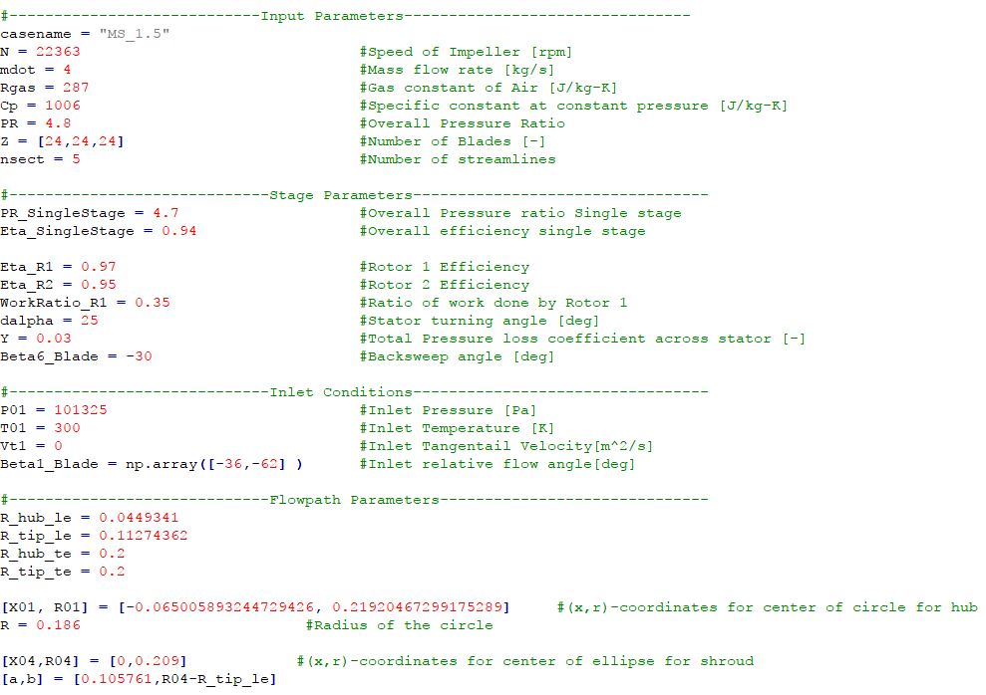

Figure 1 Sample input parameters for 1.5 stage centrifugal impeller.

1. **Output of flow parameters at meanline**

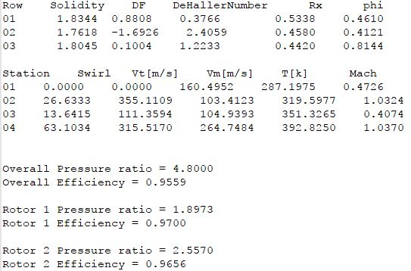

Figure 2 Sample output of meanlineflowparameters.dat for 1.5 stage centrifugal impeller.